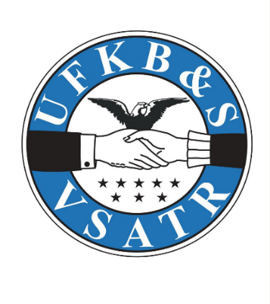
Eligibility Requirements:
- High School Senior
- Student must attend accredited post-secondary education program within 2 years of high school graduation.
- Applicants must have relationship to a UFKB&S/Friends of Suomi Hall (Astoria Lodge) by being a member, related to a member or descendant of a past member
- Completed application
- 2 letters of recommendation
  - 1 from school faculty member, 1 from other member of community (family friend, employer, etc.)
- Copy of transcript(s)

Mail completed scholarship application by May 10, 2026, to:
Friends of Suomi Hall
Attn Scholarship Committee
PO Box 146
Astoria, OR 97103

Selected applicants will be awarded scholarships in June during awards nights at schools or will be contacted by committee member. Instructions for redeeming scholarship will be given then.
Name:

Preferred Pronoun:

Mailing Address:

Phone number:

Permanent email address (not your school address):

Parent/Guardian name(s):

Intended university, college or trade school or schools applied to if have not decided:

Planned subject of study:

Student signature:

Date:

Please answer all the following questions
- Who in your family has been part of the Astoria Finnish Brotherhood Lodge?

- Please list activities you have participated in during your high school career. This can include extracurricular activities (sports, band, etc.), work, volunteering/community service, hobbies. Please include the years you participated, and any honors/special recognition received.
Example:
- Choir, freshman and sophomore years, voted Most Inspirational
- Cashier at Dairy Queen, 2024-25
- Helped hand out registration packets at Great Columbia Bridge Run, 2023

- What are your educational goals? What would you like to study and what kind of career? Why did you choose this field? How do you plan to finance your education? (short essay)

- What is your Finnish heritage and/or interest in Nordic culture? How has this been part of your life? (short essay)

